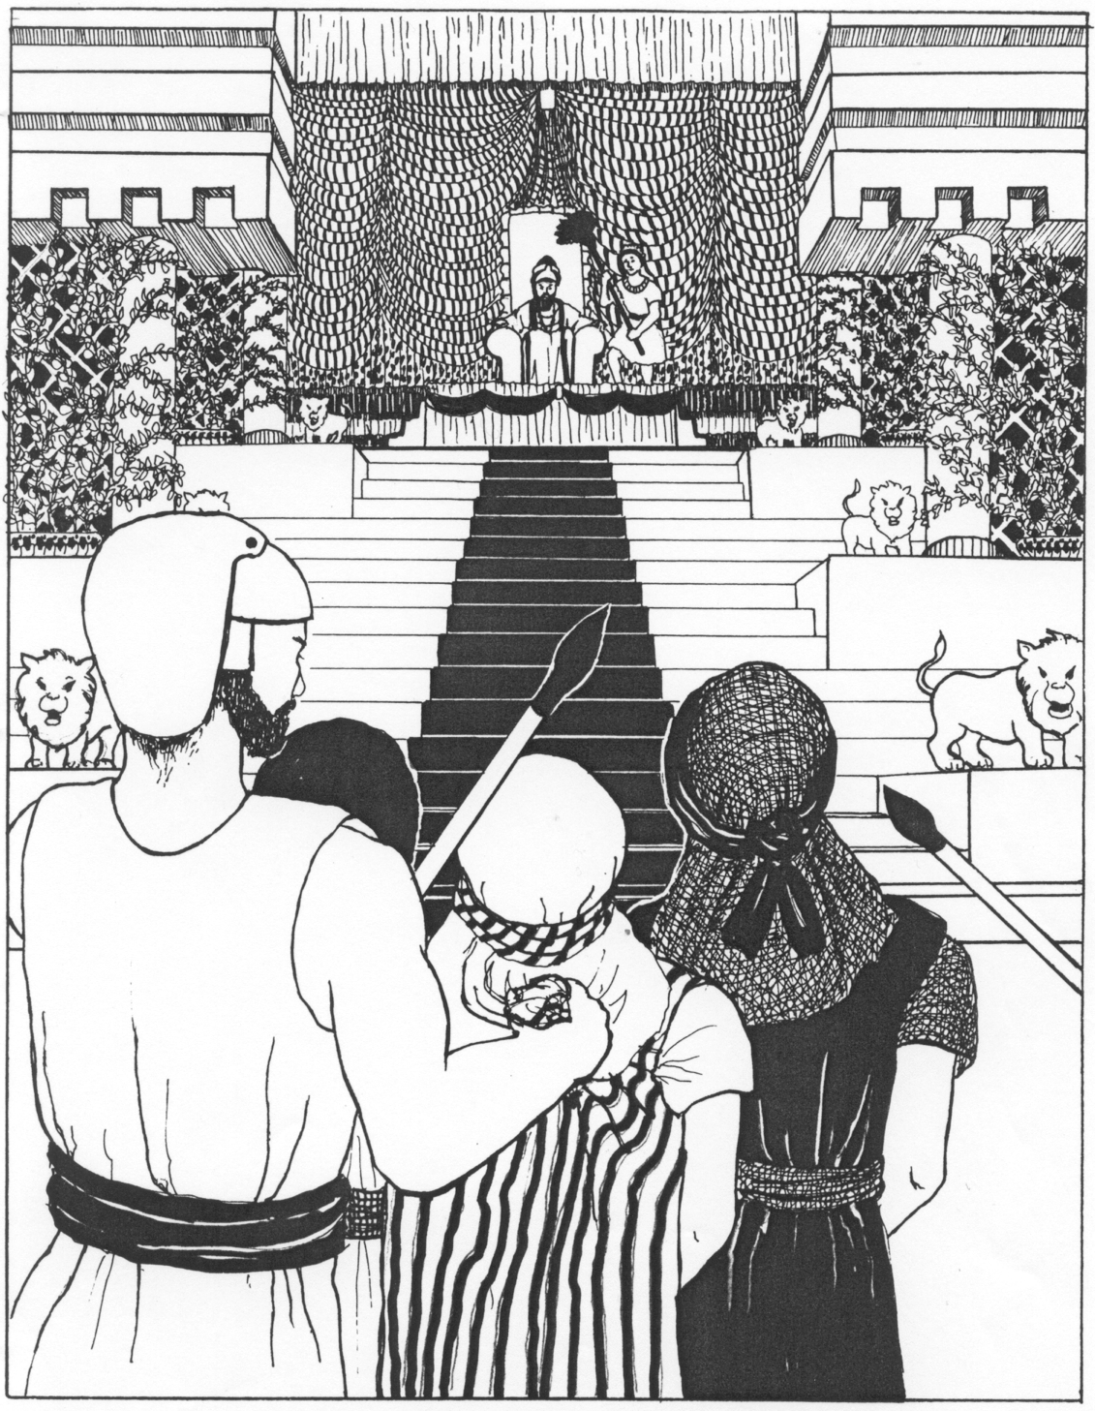

Session 1: Daniel 5 – The Writing on the Wall

Overview
Belshazzar, king of Babylon, holds a big feast using the holy cups from God’s temple. Suddenly, a mysterious hand writes on the wall. None of the wise men can read it, but Daniel explains the meaning: God has judged the king, and his kingdom will fall. That very night, Babylon is conquered.

Section 1: The Feast (vv.1–4)
- Why do you think Belshazzar used the temple vessels for his party?
______________________________________________________________________________
______________________________________________________________________________
______________________________________________________________________________
- What does this show about his attitude toward God?
______________________________________________________________________________
______________________________________________________________________________
______________________________________________________________________________
- Think of something people treat as “no big deal” today that God sees as important. What comes to mind?
______________________________________________________________________________
______________________________________________________________________________
______________________________________________________________________________
______________________________________________________________________________
______________________________________________________________________________
______________________________________________________________________________

_____________________________________________________________________

Section 2: The Writing Appears (vv.5–9)
- Imagine if you were at Belshazzar’s party—how would you react if a man’s hand appeared and started writing on the wall?
______________________________________________________________________________
______________________________________________________________________________
______________________________________________________________________________
- Why do you think the wise men couldn’t read it?
______________________________________________________________________________
______________________________________________________________________________
______________________________________________________________________________
- Give some examples of when we need God’s help.
______________________________________________________________________________
______________________________________________________________________________
______________________________________________________________________________
- Should we seek God’s help only when there is a difficult challenge in front of us?
______________________________________________________________________________
______________________________________________________________________________
______________________________________________________________________________
Section 3: Daniel’s Answer (vv.10–29)
- The Queen remembers Daniel (see vv.10-12). It is good to have a reputation for faithfulness like Daniel had? Explain why.
______________________________________________________________________________
______________________________________________________________________________
______________________________________________________________________________
- Daniel reminds Belshazzar of what happened to Nebuchadnezzar (vv.18–23). What lesson had Belshazzar failed to learn?
______________________________________________________________________________
______________________________________________________________________________
______________________________________________________________________________
The message “MENE, MENE, TEKEL, UPHARSIN” means: God has numbered your kingdom, you’ve been weighed and found wanting, and your kingdom will be divided.
- What does it mean to be “weighed and found wanting”? What would be a comparison to be “weighed and found wanting” in today’s time?
______________________________________________________________________________
______________________________________________________________________________
______________________________________________________________________________
- How things should we do to be prepared so we are found faithful?
______________________________________________________________________________
______________________________________________________________________________
______________________________________________________________________________

Other Notes:
______________________________________________________________________________
______________________________________________________________________________
______________________________________________________________________________
______________________________________________________________________________
______________________________________________________________________________
______________________________________________________________________________
______________________________________________________________________________
______________________________________________________________________________

Session 2: Daniel 6 – Daniel in the Lions’ Den

Overview
A new kingdom, the Medes and Persians, takes power. Jealous rulers trick King Darius into signing a law against prayer. Daniel refuses to stop praying to God and is thrown into a den of lions—but God saves him.

Section 1: A Trap Set (vv.1–9)
- Why did the rulers want to trap Daniel?
______________________________________________________________________________
______________________________________________________________________________
______________________________________________________________________________
- If someone wanted to “find fault” in your life, what part of your faith would they see most clearly?
______________________________________________________________________________
______________________________________________________________________________
______________________________________________________________________________

Section 2: Daniel’s Faith (vv.10–17)
- Daniel prayed three times a day. Why didn’t he try to hide?
______________________________________________________________________________
______________________________________________________________________________
______________________________________________________________________________
- Have you ever been pressured to hide your faith (at school, with friends, online)?
______________________________________________________________________________
______________________________________________________________________________
______________________________________________________________________________
- If you were in Daniel’s position, what do you think you would you have done?
______________________________________________________________________________
______________________________________________________________________________
______________________________________________________________________________
Section 3: God’s Deliverance (vv.18–28)
- What does King Darius do during the night while Daniel is in the den?
______________________________________________________________________________
______________________________________________________________________________
______________________________________________________________________________
- How does this show his respect for Daniel’s God?
______________________________________________________________________________
______________________________________________________________________________
______________________________________________________________________________
- What lesson do we learn about God’s power to save?
______________________________________________________________________________
______________________________________________________________________________
______________________________________________________________________________

Other Notes:
______________________________________________________________________________
______________________________________________________________________________
______________________________________________________________________________
______________________________________________________________________________
______________________________________________________________________________

Session 3: Daniel 7 – The Four Beasts & the Kingdom of God

Overview
Daniel dreams of four beasts (a lion, a bear, a leopard, and a terrifying beast). Each represents a world empire. But in the end, God gives His everlasting kingdom to “one like the Son of man.”

Section 1: The Four Beasts (vv.1–8)
- Draw or describe the four beasts. Which one seems the scariest?
______________________________________________________________________________
______________________________________________________________________________
______________________________________________________________________________
______________________________________________________________________________
______________________________________________________________________________
______________________________________________________________________________
______________________________________________________________________________
______________________________________________________________________________
______________________________________________________________________________
- Why do you think beasts (animals) are used to describe kingdoms?
______________________________________________________________________________
______________________________________________________________________________
______________________________________________________________________________
- What do these beasts tell us about human power and governments?
______________________________________________________________________________
______________________________________________________________________________
______________________________________________________________________________

Section 2: The Ancient of Days (vv.9–14)
- List the qualities of the “Ancient of Days” (vv.9-10). What stands out most to you? Can you find other places in the bible where these type of descriptions are used?
______________________________________________________________________________
______________________________________________________________________________
______________________________________________________________________________
______________________________________________________________________________
- What does it mean that the “Son of man” receives a kingdom that lasts forever (v.14)?
______________________________________________________________________________
______________________________________________________________________________
______________________________________________________________________________
- How does this vision give hope to us, even when things look scary on earth?
______________________________________________________________________________
______________________________________________________________________________
______________________________________________________________________________
- Bonus question: Do you have any thoughts about what “Ancient of days” means and what “Son of man” means? Do they describe the same thing or do these terms descript something different? (Feel open to ask this in the study class.)
______________________________________________________________________________
______________________________________________________________________________
______________________________________________________________________________
______________________________________________________________________________
______________________________________________________________________________
______________________________________________________________________________

Section 3: The Meaning Explained (vv.15–28)
- Daniel interprets the vision and notes that the four great beasts are “four kings”. Can you identify what each of the four beast represents?
______________________________________________________________________________
______________________________________________________________________________
______________________________________________________________________________
______________________________________________________________________________
- In the fourth beast there is the “little horn” (vv. 8, 21-22). This little horns speaks against God? Do you have any thoughts as to who or what this little horn represents?
______________________________________________________________________________
______________________________________________________________________________
______________________________________________________________________________
- What does it mean that “the saints of the most High shall take the kingdom”?
______________________________________________________________________________
______________________________________________________________________________
______________________________________________________________________________
______________________________________________________________________________
______________________________________________________________________________
- Daniel feels troubled by the vision. Why do you think he is troubled?
______________________________________________________________________________
______________________________________________________________________________
______________________________________________________________________________
______________________________________________________________________________
______________________________________________________________________________

Session 4: Daniel 8 – The Ram and the Goat

Overview
Daniel sees a vision of a ram and a goat fighting. The ram represents the Medo-Persian empire, the goat represents Greece, and the “little horn” points to a powerful, prideful ruler. Once again, God shows that He rules over all history.

Section 1: The Vision (vv.1–14)
- What do the ram and the goat represent?
______________________________________________________________________________
______________________________________________________________________________
______________________________________________________________________________
- Why do you think God used animals in visions instead of just naming kingdoms?
______________________________________________________________________________
______________________________________________________________________________
______________________________________________________________________________
- What happens when the “little horn” becomes powerful (v.9)?
______________________________________________________________________________
______________________________________________________________________________
______________________________________________________________________________

Section 2: Gabriel Explains the Vision (vv.15–27)
- Who helps Daniel understand the vision?
______________________________________________________________________________
______________________________________________________________________________
______________________________________________________________________________
______________________________________________________________________________
- Why is it comforting that God sends angels to explain?
______________________________________________________________________________
______________________________________________________________________________
______________________________________________________________________________
- Daniel feels sick after the vision. Why do you think the future events affected him so much?
______________________________________________________________________________
______________________________________________________________________________
______________________________________________________________________________
- How do you feel when thinking about the future—excited, worried, or both? Where do we gain comfort when we learn of prophesies of troubling times ahead?
______________________________________________________________________________
______________________________________________________________________________
______________________________________________________________________________
______________________________________________________________________________

Final Thoughts: List at least four lessons from Daniel chapters 5-8
______________________________________________________________________________
______________________________________________________________________________
______________________________________________________________________________
______________________________________________________________________________
______________________________________________________________________________
______________________________________________________________________________
______________________________________________________________________________
______________________________________________________________________________

